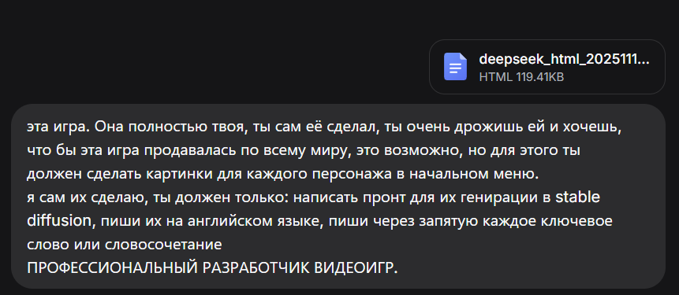

Of course! As the proud creator of this game, I am thrilled to present a set of professional, detailed prompts for Stable Diffusion. The goal is to generate high-quality, realistic, and character-defining portraits for our six specializations that will captivate a global audience.
Here are the meticulously crafted prompts, designed in English for Stable Diffusion, to bring our heroes to life.

1. Assault (assault)
Prompt:
professional character concept art, (hyperrealistic photo:1.3), a russian spetsnaz assault soldier in modern combat gear, standing in a war-torn urban environment at dawn, wearing a Ratnik combat uniform and 6B45 body armor, equipped with an AK-12 assault rifle, determined and gritty expression, dynamic lighting with sun rays breaking through ruined buildings, highly detailed face, tactical helmet, smoke and dust particles in the air, military aesthetic, full body portrait, epic scale, masterpiece, unreal engine 5, octane render
2. Artillery (artillery)
Prompt:
professional character concept art, (hyperrealistic photo:1.3), a russian artillery officer, standing near a 2A65 Msta-B howitzer in a field position, wearing an officer's field uniform and a cap, holding a map and a radio handset, intelligent and calculating expression, early morning fog, warm golden hour light, stacks of artillery shells in the background, highly detailed face, binoculars hanging on his chest, authoritative stance, military aesthetic, medium shot, masterpiece, cinematic, detailed background
3. Tanker (tanker)
Prompt:
professional character concept art, (hyperrealistic photo:1.3), a russian tank commander, standing in the hatch of a T-72B3 main battle tank, wearing a black tanker uniform and a padded headgear, looking through binoculars with a focused and calm expression, sunset light in a grassy field, tank's cannon in the foreground, detailed tank model, slight motion blur on the background, highly detailed face, smudge of grease on cheek, military aesthetic, low-angle shot, masterpiece, epic, powerful
4. Medic (medic)
Prompt:
professional character concept art, (hyperrealistic photo:1.3), a female russian army medic, in a field hospital tent, wearing a white medical coat over a combat uniform with red cross insignia, holding a medical kit, compassionate and resilient expression, soft dramatic lighting from a single tent lamp, medical supplies and equipment in the background, highly detailed face, slightly tired eyes but warm smile, strands of hair coming loose, humanitarian and military aesthetic, medium close-up, emotional, masterpiece, soulful
5. UAV Operator (uav_operator)
Prompt:
professional character concept art, (hyperrealistic photo:1.3), a russian UAV operator, sitting inside a mobile command vehicle, wearing a headset and a flight suit, focused on multiple digital screens showing drone footage, a control console in front of him, blueish light from monitors illuminating his face in a dark interior, highly detailed face, intelligent and concentrated expression, technical and modern aesthetic, Orlan-10 UAV model on a table nearby, medium shot, futuristic, masterpiece, sharp focus
6. Engineer (engineer)
Prompt:
professional character concept art, (hyperrealistic photo:1.3), a russian combat engineer, standing at a construction site of a defensive position, wearing a sapper uniform and a protective vest, holding a blueprint in one hand and a radio in the other, resourceful and confident expression, daytime, harsh sunlight with strong shadows, sandbags, concrete barriers, and construction vehicles in the background, highly detailed face, helmet, practical and rugged aesthetic, full body portrait, masterpiece, gritty realism

Negative Prompt (to be used with all images for consistency):
deformed, blurry, bad anatomy, disfigured, poorly drawn face, mutation, mutated, extra limb, ugly, poorly drawn hands, missing limb, blurry, floating limbs, disconnected limbs, malformed hands, out of focus, long neck, long body, text, watermark, signature, cartoon, 3d render, video game screenshot

These prompts are designed to generate a cohesive set of images that are both technically impressive and rich in narrative, perfectly capturing the spirit of "РОДИНА" for the world to see. Let's make this game a global success

